Project Design Phase-II
Technology Stack (Architecture & Stack)
WasteGuide AI — Sustainable Waste Management Assistant
The deliverable includes the architectural diagram below along with the component and characteristic breakdown in Table-1 and Table-2.

Technical Architecture
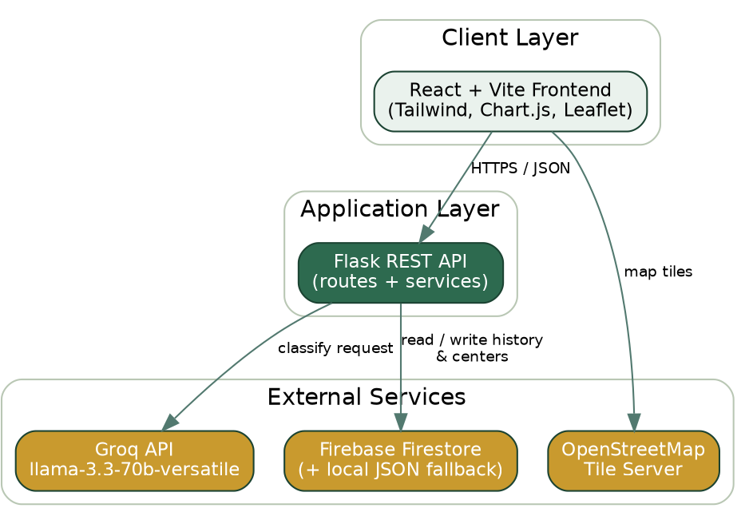

Table-1: Components & Technologies
S.No | Component | Description | Technology
1. | User Interface | • How the user interacts with the application | React 18, Vite, Tailwind CSS, React Router
2. | Application Logic-1 | • Waste classification request handling & validation | Python, Flask, Flask-CORS
3. | Application Logic-2 | • AI-based waste classification | Groq API — llama-3.3-70b-versatile
4. | Application Logic-3 | • Aggregate statistics computation | Python (services/analytics.py)
5. | Database | • Scan history & collection-center records | Firebase Firestore
6. | Cloud Database | • Managed NoSQL document store on cloud | Firebase Firestore (Google Cloud)
7. | File Storage | • Offline-first fallback data store | Local JSON file (backend/data/local_store.json)
8. | External API-1 | • Waste item classification via LLM | Groq Chat Completions API
9. | External API-2 | • Interactive maps & collection-center tiles | OpenStreetMap tile service via Leaflet.js
10. | Machine Learning Model | • Classifies waste item into category, hazard level, and disposal guidance | llama-3.3-70b-versatile (via Groq)
11. | Infrastructure (Server / Cloud) | • Application deployment  • Local Server Configuration: Flask dev server (python app.py)  • Cloud Server Configuration: Render (backend, gunicorn) + Vercel (frontend, CDN) | Render, Vercel

Table-2: Application Characteristics
S.No | Characteristics | Description | Technology
1. | Open-Source Frameworks | React, Flask, Tailwind CSS, Chart.js, Leaflet.js, React Leaflet, Axios — all used under their respective open-source licenses | React 18 / Flask 3 / Tailwind 3
2. | Security Implementations | API keys (Groq, Firebase) kept server-side only; input validation & length limits on every endpoint; CORS restricted to the deployed frontend origin | Flask-CORS, environment variables (.env)
3. | Scalable Architecture | Stateless 2-tier architecture (React client + Flask API) with the AI model and database as independent external services; frontend and backend scale and deploy independently | React + Flask, gunicorn workers
4. | Availability | Frontend served from Vercel's global CDN; backend health-checked via /api/health; Firestore failures auto-fallback to a local store instead of downtime | Vercel CDN, Render web service
5. | Performance | AI responses typically return in under 5 seconds; frontend debounces search input and paginates history to minimize re-renders and API calls | Axios timeouts, client-side debouncing & pagination

